

# COLLEGE OF ARTS AND SCIENCE UNIVERSITI UTARA MALAYSIA

**PRACTICUM STIX3912 SEMESTER I SESSION 2024/2025 (A241)**

**PROPOSAL**

# Title: Expense Tracker Appplication

**STUDENT**

**Matric No. :** 284810

**Name :** Chu Kea Qiu

**Email :** keaqiuynwa@gmail.com

**Mobile :** 011-59655960

# ORGANIZATION

**Name :** DC Technology Solutions Sdn. Bhd.

**Address :** Level 12, Menara LGB No1, Jalan Wan Kadir, Taman Tun Dr. Ismail, 60000 Kuala Lumpur

# SUPERVISOR (ORGANIZATION)

**Name :** Goh Yuen Fei

**Telephone :** +603 7610 9168

# Fax : -

**TABLE OF CONTENT**

* 1. INTRODUCTION 1
  2. Project background 1-2
  3. Problem Statement 2
  4. Objective 3
  5. Scope 3
  6. Project Significance 3
  7. PROJECT PLANNING 4
  8. Methodology 4-5
  9. Feasibility Study 6
     1. Tools 6
     2. Gantt Chart 6

3.0 SUMMARY 7

REFERENCES 8

APPENDIX 9

# INTRODUCTION

# Project background

Applications are therefore being made to solve certain problems which come up every day. It was very hectic to keep a record of every cent spent without missing any, so the world came up with what is called an expense tracker application. Most of the readily available applications in the market are full of impressive features such as synchronizing bank accounts, investment accounts, and credit cards, and also customizing of spend reports.

However, even if an application is downloaded at high rates, it does not mean that the number of active users that use it is high, too. Eduardo Barbaro et al. claim that in a mobile app, there is a need to maintain the user's attraction in order to keep them active for consuming services and creating new contents. On the other hand, there can be reasons parallel why users **abandon an app** due to other emerging apps or simply because of the decline in interest over the service it offers. Therefore, according to Chenxi Liu et al., factors such as usability, learning opportunities, social interaction, and incentives of completing tasks have a strong influence on user engagement. According to David Raso, moreover, people feel far more committed in cases when they can perform a wide range of activities. Of course, this principle could be applied to **repetitive activities** like expense tracking. While people may initially be excited about using an expense tracker, they may get bored over time due to this constant recording of expenses. As a matter of fact, it can be so unexciting for some people if the features on an app don't excite them. Apart from this, there are a lot of applications such as MyMoney, Wallet, Money Manager Expense & Budget and many more that do not offer an **expense split feature** for users. They emphasised expense management for personal use only.

This calls for the solution by addressing the problem with a new application Expense Tracker that will have several engaging features. The app being an expense manager would take benefit further by facilitating **sharing of bill amounts amongst friends and groups** for convenience. It would also **provide gamification** or the use of game design elements in non-game contexts to increase and reward certain behaviors and improve user experience. As per Ganit Richter et al., gamification has become one of the latest trends to be used across sectors like marketing, politics, health, and education and is fast gaining popularity. For instance, IT research firm Gartner predicted that by 2015, half of large companies will have incorporated gamification techniques into at least one business process. At the same time, M2 Research forecasted revenues of gamification software and services to rise to $938 million in 2014 from less than $100 million in 2011. Additionally, with the expense-splitting features available in the proposed application, users can **manage their expenses together with family or friends**. This collaboration helps increase user motivation and reduces the likelihood of abandoning the application.

Incorporating expense management, splitting, and gamification into an expense tracker app will make financial handling more enjoyable and engaging for its users.

# Problem Statement

# 1.2.1 Lack of versatile expense management solutions

The existing expense trackers lack multifunctional expenditure management solutions, as most of them do not provide personal finance management and budgeting features with collaboration, hence limiting functionality for users to handle personal expenses or group expenses.

**1.2.2 Inability to sustain user interest**

Most of the expense-tracking tools are not designed in such a manner that they keep users interested. Users get bored after a certain period of time. Without such features, tracking finances is less fun and hence used less often.

**1.2.3 Limited sense of community and collaboration**

Most of the current expense-tracking applications does not support a sense of community or teamwork, which may eventually make a person feel like he/she is all alone in managing his/her finances and hence lose motivation to achieve his/her financial goals.

# Objective

* + To develop an expense tracker application that supports for expense split among friends or groups.
  + To implement interesting gamification features in order to lighten the experience of tracking expenses and encourage more frequent application use.
  + To incorporate social and collaborative features in the application that would to develop shared motivations and supports for pursuing financial goals.

# Scope

These features within the scope of this project offer a series of enhancements to the current Expense Tracker application. It will handle expenses efficiently by recording expenditure, categorizing, and tracking expenses with ease. The bill-splitting feature inside the application will let users share their expenses quickly with friends or family. To make it more gameful, the features will also include rewards, challenges, and progress tracking. It will also provide useful analytics for users, like insights and reports on spending behavior to help them make educated decisions about their finances. Last but not least, huge attention will be paid to user interface design: an application will be worked out in the most intuitive and stylish way to enhance overall user experience.

# Project Significance

This project holds immense potential; it solves the users' common drawbacks when using expense tracker applications. Incorporating gamification and social features into financial management will render it more attractive, appealing, and enjoyable for the users, thus encouraging good spending behavior and accommodation of good financial literacy. Besides, sharing expenses with friends and groups boosts cooperation and communication; they cannot do without one another in managing their finances. Thus, the project attempts to offer solutions that can meet the continuous changes in user needs.

# PROJECT PLANNING

# Methodology

The proposed project will adopt the Agile Development methodology. It is a development approach characterized by iterative and incremental development, where there is continuous flexibility and response to needed changes from the users. Agile methodolgy is selected because it embraces changing requriements or design, even in later stages. Using this Agile approach, the project will work on a developed, user-friendly, engaging expense-tracker application needed for fitting with changing user needs and effectively delivering value.

1. Meet

* Discuss the project title with the organizational supervisor and university supervisor.
* Gather requirements from supervisors about desired features and expected tools used in the development.

1. Plan

* Conduct market research about how the proposed application can stand out from the market.
* Present the proposal to supervisors, incorporating their feedback and making required changes for approval.
* Prepare a list of features and user stories that describe stakeholder needs in the product backlog.

1. Design

* Design mock-ups for applications on every device to ensure the responsiveness and user-friendly of the application.

1. Develop ( Sprint )

* Plan for every sprint, and implement it based on the design.
* Review the code and conduct unit testing and integration testing.
* Gather user feedback regarding the effectiveness and usability of the implemented features.
* Reflect on sprint successes and challenges, discussing what worked well and what didn’t.

1. Test, Launch and Evaluate

* Implement continuous testing to ensure every functionality in the application works as intended.
* Deploy the application in the server, ensuring the targeted audience can access it.
* Listen to user feedback, assess it and enhance it in future.

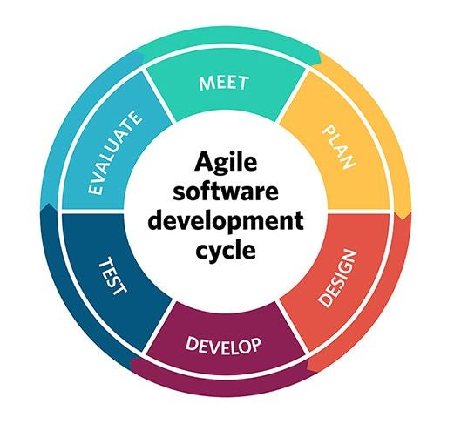

**Figure 2.1.1 Agile Methodolgoy**

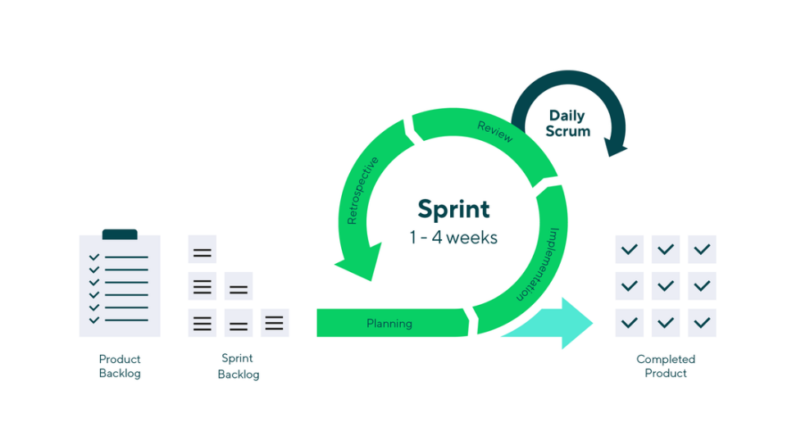

**Figure 2.1.2 Sprint**

# Feasibility Study

# This feasibility study examines the feasibility of developing the Expense Tracker Application. The analysis considers the development tools and the projected timeline, represented through a Gantt chart.

# Tools

**Project Management Tools**: Trello

# User Interface Design Tools: Figma

**Development Environments**: Visual Studio Code

**Framework**: Next.js

**Backend as a Service (BaaS)**: Firebase (Firebase Authentication, Cloud Firestore, Cloud Storage)

**Machine Learning Tools**: TensorFlow

**Gamification Frameworks:** Gamify

**Deployment Platforms**: Vercel

# Gantt Chart

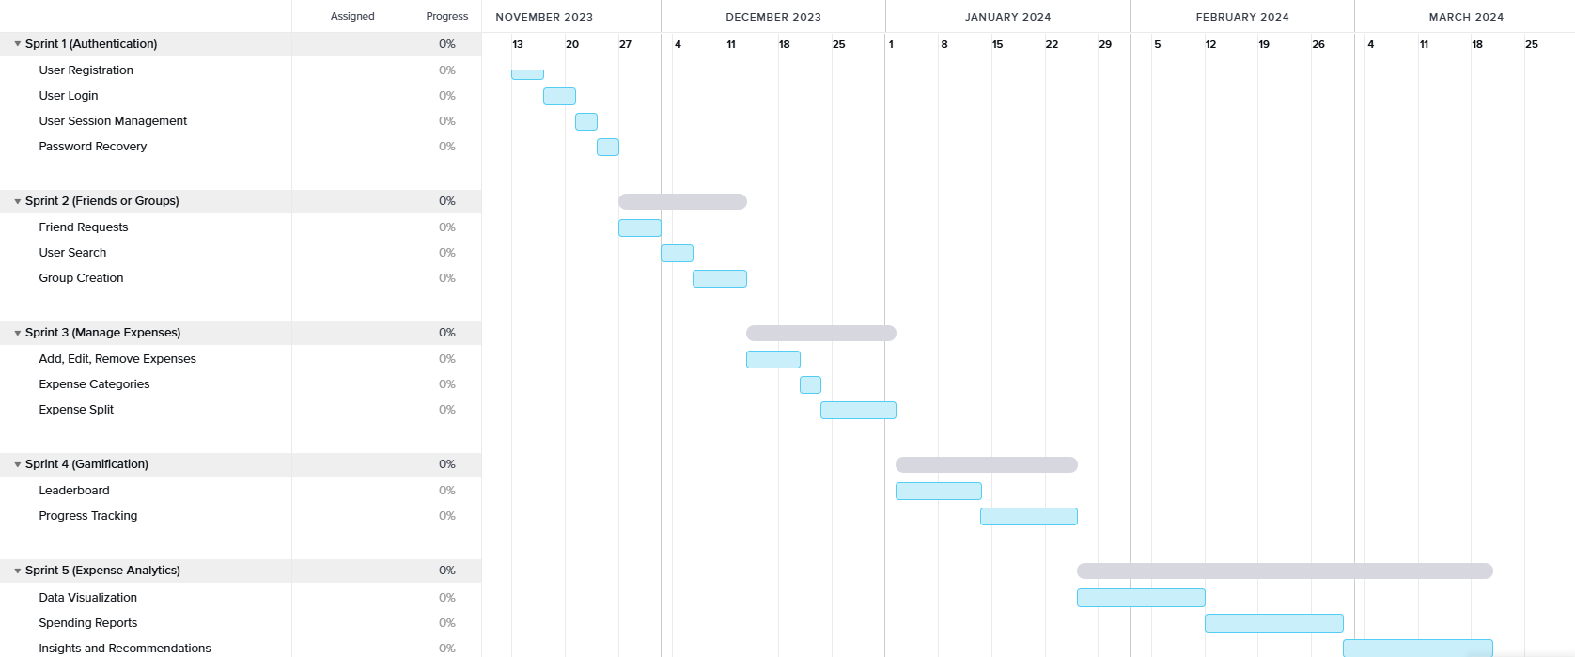

**Figure 2.2.2 Gantt Chart**

# 3.0 SUMMARY

The proposed Expense Tracker Application will bring in new mechanisms to push away hindrances that naturally come into play in the few available existing expense-tracking tools today. This will be an adaptable tool, comprising the essential features of recording, categorizing, and tracking expenses, with novel features like splitting expenses among friends and groups.

In addition, rewarding, challenging, and tracking progress will make the process of financial management more game-like within the application. On the other hand, by allowing social features, a user will have that feeling of community, hence can support each other in achieving financial goals and managing expenses collectively.

According to the Agile Development approach, flexibility and responsiveness in regard to feedback is crucial throughout the whole project life cycle, including the requirement-gathering phase, design, iterative development sprints, continuous testing, and deployment. Key development tools on this strongly technologically-based project were identified through a feasibility study. This includes, but is not limited to, Trello for project management, Figma for UI design, and Firebase for backend services. Structured development on the project timeline is supported by maintaining a Gantt chart.

The ultimate vision is to ensure that an accessible and user-friendly comprehensive solution for expense tracking grows along with the users to enhance financial literacy and promote responsible spending behavior.

# REFERENCES

‌Barbaro, E., Grua, E. M., Malavolta, I., Stercevic, M., Weusthof, E., & Van Den Hoven, J. (2019). *Modelling and predicting User Engagement in mobile applications.* Data Science, 3(2), 61–77. <https://doi.org/10.3233/ds-190027>

Chenxi Liu & Ana-Paula Correia. (2021, December). *A Case Study of Learners’ Engagement in Mobile Learning Applications.* ResearchGate. <https://www.researchgate.net/publication/356952691_A_Case_Study_of_Learners'_Engagement_in_Mobile_Learning_Applications>

Gurnov, A. (2024). *What is Agile Methodology in Project Management?* Wrike. https://www.wrike.com/project-management-guide/faq/what-is-agile-methodology-in-project-management/

Raso, D., Olsson, J., & Larsson, R. (2019). *How does the removal of repetitive tasks affect motivation? -A study of motivation within shared service centers.* <https://lup.lub.lu.se/luur/download?func=downloadFile&recordOId=8990262&fileOId=8990263>

Richter, G., Raban, D. R., & Rafaeli, S. (2014). *Studying Gamification: The Effect of Rewards and Incentives on Motivation. Gamification in Education and Business, 21–46*. <https://doi.org/10.1007/978-3-319-10208-5_2>

‌

‌

# APPENDIX

**Prepared by:**

Student’s Signature Date:

28 Oct 2024



( CHU KEA QIU )

# Endorsed by:

Organization’s Supervisor Signature Date:

( )

Company’s Stamp: